Android Application Development Course (65- hours)

Session 1 - Introduction & Environment Setup
Introduction, What is open source?
Mobile Application Development Overview
Mobile Devices Profiles, Mobile Software, Options for development

Installing & Configuring Development Environment
NetBeans, Android SDK, Android Studio

Session 2 - Basic Concept of OOP
Basic Concept of OOP
Concept of Class & Object, Inheritance & Interface, Access control & Scope, Overloading & Overriding

Session 3 -
Working with OOP

Session 4 – Make first Android Application
Design related issues. Layout and android project structure

Session 5 - Basic User Interface
Basic User Interfaces
XML Layouts, Linear Layout, Frame Layout, Table Layout, Relative Layout,

The basic building block for user interface is a View object which is created from the View class and occupies a rectangular area on the screen and is responsible for drawing and event handling. View is the base class for widgets, which are used to create interactive UI components like buttons, text fields, etc.
The ViewGroup is a subclass of View and provides invisible container that hold other Views or other ViewGroups and define their layout properties.
At third level we have different layouts which are subclasses of ViewGroup class and a typical layout defines the visual structure for an Android user interface and can be created either at run time using View/ViewGroup objects or you can declare your layout using simple XML file main_layout.xml which is located in the res/layout folder of your project.
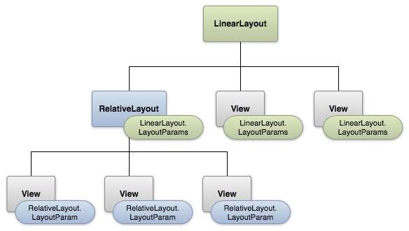

Layout params
This tutorial is more about creating your GUI based on layouts defined in XML file. A layout may contain any type of widgets such as buttons, labels, textboxes, and so on. Following is a simple example of XML file having LinearLayout −
<?xml version="1.0" encoding="utf-8"?>
<LinearLayout xmlns:android="http://schemas.android.com/apk/res/android"
android:layout_width="fill_parent"
android:layout_height="fill_parent"
android:orientation="vertical" >

<TextView android:id="@+id/text"
android:layout_width="wrap_content"
android:layout_height="wrap_content"
android:text="This is a TextView" />

<Button android:id="@+id/button"
android:layout_width="wrap_content"
android:layout_height="wrap_content"
android:text="This is a Button" />

<!-- More GUI components go here -->

</LinearLayout>
Once your layout has created, you can load the layout resource from your application code, in your Activity.onCreate() callback implementation as shown below −
public void onCreate(Bundle savedInstanceState) {
super.onCreate(savedInstanceState);
setContentView(R.layout.activity_main);
}

Android Layout Types
There are number of Layouts provided by Android which you will use in almost all the Android applications to provide different view, look and feel.
Sr.No | Layout & Description
1 | Linear Layout  LinearLayout is a view group that aligns all children in a single direction, vertically or horizontally.
2 | Relative Layout  RelativeLayout is a view group that displays child views in relative positions.
3 | Table Layout  TableLayout is a view that groups views into rows and columns.
4 | Absolute Layout  AbsoluteLayout enables you to specify the exact location of its children.
5 | Frame Layout  The FrameLayout is a placeholder on screen that you can use to display a single view.
6 | List View  ListView is a view group that displays a list of scrollable items.
7 | Grid View  GridView is a ViewGroup that displays items in a two-dimensional, scrollable grid.

Layout Attributes
Each layout has a set of attributes which define the visual properties of that layout. There are few common attributes among all the layouts and their are other attributes which are specific to that layout. Following are common attributes and will be applied to all the layouts:
Sr.No | Attribute & Description
1 | android:id  This is the ID which uniquely identifies the view.
2 | android:layout_width  This is the width of the layout.
3 | android:layout_height  This is the height of the layout
4 | android:layout_marginTop  This is the extra space on the top side of the layout.
5 | android:layout_marginBottom  This is the extra space on the bottom side of the layout.
6 | android:layout_marginLeft  This is the extra space on the left side of the layout.
7 | android:layout_marginRight  This is the extra space on the right side of the layout.
8 | android:layout_gravity  This specifies how child Views are positioned.
9 | android:layout_weight  This specifies how much of the extra space in the layout should be allocated to the View.
10 | android:layout_x  This specifies the x-coordinate of the layout.
11 | android:layout_y  This specifies the y-coordinate of the layout.
12 | android:layout_width  This is the width of the layout.
13 | android:layout_width  This is the width of the layout.
14 | android:paddingLeft  This is the left padding filled for the layout.
15 | android:paddingRight  This is the right padding filled for the layout.
16 | android:paddingTop  This is the top padding filled for the layout.
17 | android:paddingBottom  This is the bottom padding filled for the layout.
Here width and height are the dimension of the layout/view which can be specified in terms of dp (Density-independent Pixels), sp ( Scale-independent Pixels), pt ( Points which is 1/72 of an inch), px( Pixels), mm ( Millimeters) and finally in (inches).
You can specify width and height with exact measurements but more often, you will use one of these constants to set the width or height −
- android:layout_width=wrap_content tells your view to size itself to the dimensions required by its content.
- android:layout_width=fill_parent tells your view to become as big as its parent view.
Gravity attribute plays important role in positioning the view object and it can take one or more (separated by '|') of the following constant values.
Constant | Value | Description
top | 0x30 | Push object to the top of its container, not changing its size.
bottom | 0x50 | Push object to the bottom of its container, not changing its size.
left | 0x03 | Push object to the left of its container, not changing its size.
right | 0x05 | Push object to the right of its container, not changing its size.
center_vertical | 0x10 | Place object in the vertical center of its container, not changing its size.
fill_vertical | 0x70 | Grow the vertical size of the object if needed so it completely fills its container.
center_horizontal | 0x01 | Place object in the horizontal center of its container, not changing its size.
fill_horizontal | 0x07 | Grow the horizontal size of the object if needed so it completely fills its container.
center | 0x11 | Place the object in the center of its container in both the vertical and horizontal axis, not changing its size.
fill | 0x77 | Grow the horizontal and vertical size of the object if needed so it completely fills its container.
clip_vertical | 0x80 | Additional option that can be set to have the top and/or bottom edges of the child clipped to its container's bounds. The clip will be based on the vertical gravity: a top gravity will clip the bottom edge, a bottom gravity will clip the top edge, and neither will clip both edges.
clip_horizontal | 0x08 | Additional option that can be set to have the left and/or right edges of the child clipped to its container's bounds. The clip will be based on the horizontal gravity: a left gravity will clip the right edge, a right gravity will clip the left edge, and neither will clip both edges.
start | 0x00800003 | Push object to the beginning of its container, not changing its size.
end | 0x00800005 | Push object to the end of its container, not changing its size.

View Identification
A view object may have a unique ID assigned to it which will identify the View uniquely within the tree. The syntax for an ID, inside an XML tag is −
android:id="@+id/my_button"
Following is a brief description of @ and + signs −
- The at-symbol (@) at the beginning of the string indicates that the XML parser should parse and expand the rest of the ID string and identify it as an ID resource.
- The plus-symbol (+) means that this is a new resource name that must be created and added to our resources. To create an instance of the view object and capture it from the layout, use the following −
Button myButton = (Button) findViewById(R.id.my_button);

Common UI Components
Edit Text, Button, checkbox
Initiate Project Selection

Session 6 - Activities & Intents
Activities
Creating an Activities, Declaring Activities in the manifest, Starting an Activity, Starting an Activity for Result, Shutting down an Activity

Intents
Intent Object, Intent Resolution, Intent Filter
An activity represents a single screen with a user interface just like window or frame of Java.Android activity is the subclass of ContextThemeWrapper class.
If you have worked with C, C++ or Java programming language then you must have seen that your program starts from main() function. Very similar way, Android system initiates its program with in an Activity starting with a call on onCreate() callback method. There is a sequence of callback methods that start up an activity and a sequence of callback methods that tear down an activity as shown in the below Activity life cycle diagram: (image courtesy : android.com )
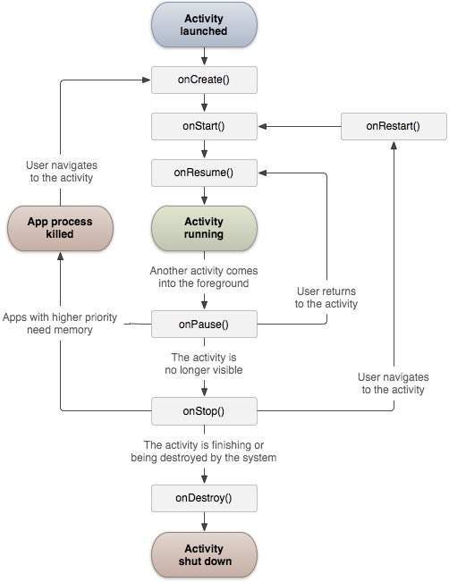
The Activity class defines the following call backs i.e. events. You don't need to implement all the callbacks methods. However, it's important that you understand each one and implement those that ensure your app behaves the way users expect.
Sr.No | Callback & Description
1 | onCreate()  This is the first callback and called when the activity is first created.
2 | onStart()  This callback is called when the activity becomes visible to the user.
3 | onResume()  This is called when the user starts interacting with the application.
4 | onPause()  The paused activity does not receive user input and cannot execute any code and called when the current activity is being paused and the previous activity is being resumed.
5 | onStop()  This callback is called when the activity is no longer visible.
6 | onDestroy()  This callback is called before the activity is destroyed by the system.
7 | onRestart()  This callback is called when the activity restarts after stopping it.

Example
This example will take you through simple steps to show Android application activity life cycle. Follow the following steps to modify the Android application we created in Hello World Example chapter −
Step | Description
1 | You will use Android studio to create an Android application and name it as HelloWorld under a package com.example.helloworld as explained in the Hello World Example chapter.
2 | Modify main activity file MainActivity.java as explained below. Keep rest of the files unchanged.
3 | Run the application to launch Android emulator and verify the result of the changes done in the application.
Following is the content of the modified main activity file src/com.example.helloworld/MainActivity.java. This file includes each of the fundamental life cycle methods. The Log.d() method has been used to generate log messages −
package com.example.helloworld;

import android.os.Bundle;
import android.app.Activity;
import android.util.Log;

public class MainActivity extends Activity {
String msg = "Android : ";

/** Called when the activity is first created. */
@Override
public void onCreate(Bundle savedInstanceState) {
super.onCreate(savedInstanceState);
setContentView(R.layout.activity_main);
Log.d(msg, "The onCreate() event");
}

/** Called when the activity is about to become visible. */
@Override
protected void onStart() {
super.onStart();
Log.d(msg, "The onStart() event");
}

/** Called when the activity has become visible. */
@Override
protected void onResume() {
super.onResume();
Log.d(msg, "The onResume() event");
}

/** Called when another activity is taking focus. */
@Override
protected void onPause() {
super.onPause();
Log.d(msg, "The onPause() event");
}

/** Called when the activity is no longer visible. */
@Override
protected void onStop() {
super.onStop();
Log.d(msg, "The onStop() event");
}

/** Called just before the activity is destroyed. */
@Override
public void onDestroy() {
super.onDestroy();
Log.d(msg, "The onDestroy() event");
}
}
An activity class loads all the UI component using the XML file available in res/layout folder of the project. Following statement loads UI components from res/layout/activity_main.xml file:
setContentView(R.layout.activity_main);
An application can have one or more activities without any restrictions. Every activity you define for your application must be declared in your AndroidManifest.xml file and the main activity for your app must be declared in the manifest with an <intent-filter> that includes the MAIN action and LAUNCHER category as follows:
<?xml version="1.0" encoding="utf-8"?>
<manifest xmlns:android="http://schemas.android.com/apk/res/android"
package="com.example.tutorialspoint7.myapplication">

<application
android:allowBackup="true"
android:icon="@mipmap/ic_launcher"
android:label="@string/app_name"
android:supportsRtl="true"
android:theme="@style/AppTheme">
<activity android:name=".MainActivity">
<intent-filter>
<action android:name="android.intent.action.MAIN" />

<category android:name="android.intent.category.LAUNCHER" />
</intent-filter>
</activity>
</application>

</manifest>
If either the MAIN action or LAUNCHER category are not declared for one of your activities, then your app icon will not appear in the Home screen's list of apps.
Let's try to run our modified Hello World! application we just modified. I assume you had created your AVD while doing environment setup. To run the app from Android studio, open one of your project's activity files and click Run icon from the toolbar. Android studio installs the app on your AVD and starts it and if everything is fine with your setup and application, it will display Emulator window and you should see following log messages in LogCat window in Android studio −
08-23 10:32:07.682 4480-4480/com.example.helloworld D/Android :: The onCreate() event
08-23 10:32:07.683 4480-4480/com.example.helloworld D/Android :: The onStart() event
08-23 10:32:07.685 4480-4480/com.example.helloworld D/Android :: The onResume() event
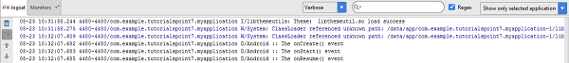
Let us try to click lock screen button on the Android emulator and it will generate following events messages in LogCat window in android studio:
08-23 10:32:53.230 4480-4480/com.example.helloworld D/Android :: The onPause() event
08-23 10:32:53.294 4480-4480/com.example.helloworld D/Android :: The onStop() event
Let us again try to unlock your screen on the Android emulator and it will generate following events messages in LogCat window in Android studio:
08-23 10:34:41.390 4480-4480/com.example.helloworld D/Android :: The onStart() event
08-23 10:34:41.392 4480-4480/com.example.helloworld D/Android :: The onResume() event
Next, let us again try to click Back button on the Android emulator and it will generate following events messages in LogCat window in Android studio and this completes the Activity Life Cycle for an Android Application.
08-23 10:37:24.806 4480-4480/com.example.helloworld D/Android :: The onPause() event
08-23 10:37:25.668 4480-4480/com.example.helloworld D/Android :: The onStop() event
08-23 10:37:25.669 4480-4480/com.example.helloworld D/Android :: The onDestroy() event

Session 7 - Activities & Intents (Cont.)
Session 8
Basic User Interfaces- Common UI Components
Selection Widgets, Date and Time Tabs, Using Menus, Using Fonts, Dialog Boxes: Alert Dialog & Toast
The Web View and the Web Kit Browser

Session 9
Basic List and Grid view
Finalizing Project Specification, Set module/phase wise Deadline

Session 10 - Using OS resources
Music Player

Session 11 – Web View
Create a web browser.

Session 11 - Data Storage
Storage Data
Shared Preferences, SQLite Database

Session 12
. Data Storage continue

Session 13 - – Services and Broadcast Receiver
Basics, Declaring a Service in the manifest, creating a Service, Starting a Service, Stopping a Service
Broadcast receiver register and unregister and project review

Session 15 – Animations
Property Animation, View Animation, Draw able Animation

Session 16 - API
API
Sending and receiving data to web and show in android

Session 17 - API
API continue

Session 18 - Content Providers
Content Provider Basics, Creating a Content Provider, Experimenting a default Content Provider

Session 19 – Google Map
Telephony background and terms, Accessing telephony information, Interaction with the phone
Working with messaging SMS
Session 20 – Map continue

Session 21- Project Review & Remarking (END)

Please Contact:-
IBCS-PRIMAX Software (BD) Ltd, House # 51, Road # 10/a, Dhanmondi, Dhaka-1209
Phone- 8110699, 01713397567-8, Email-karahman@ibcs-primax.com

